Dear Ridhi,

I have deleted the completed tasks and updated the remaining outstanding issues to be fixed.

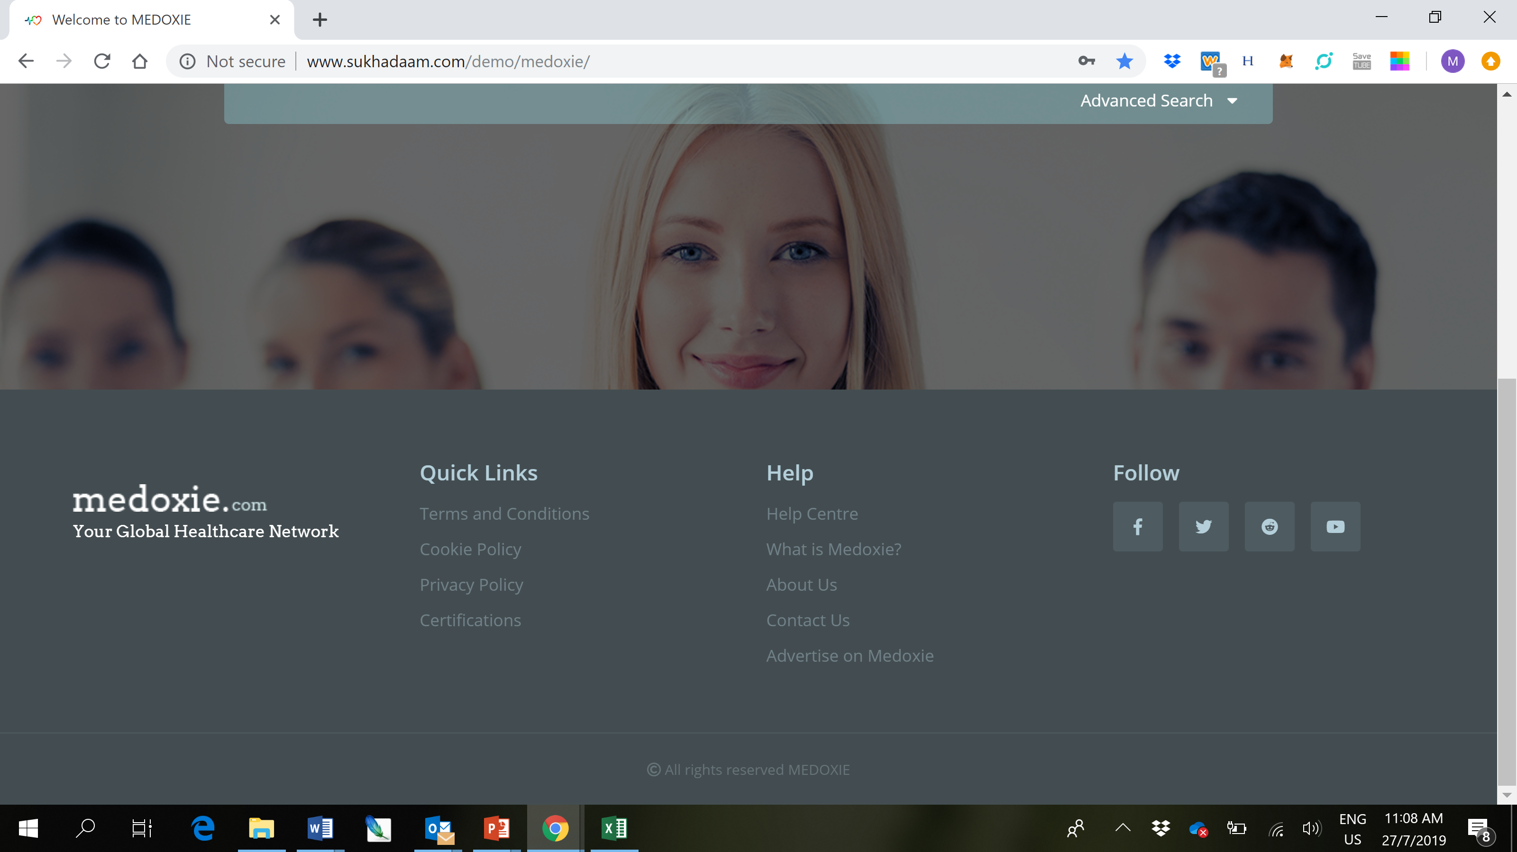

When a user presses on the “Advertise on Medoxie” the advertisement form should be displayed (see below). It will give people quick access to advertise from the homepage.

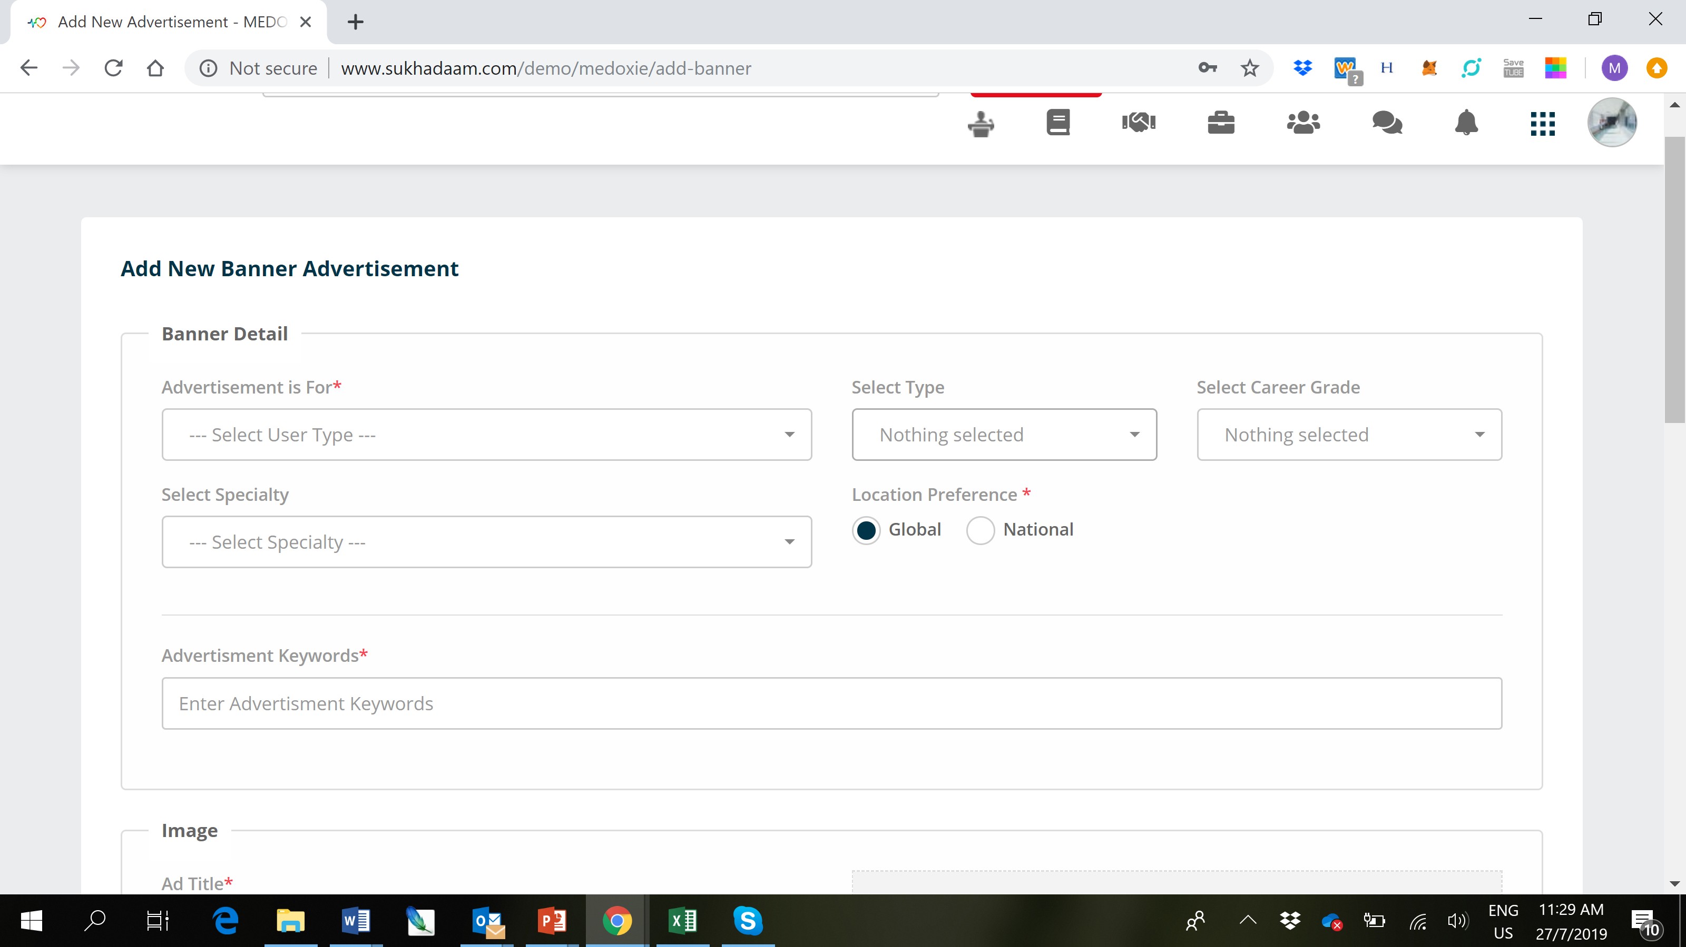

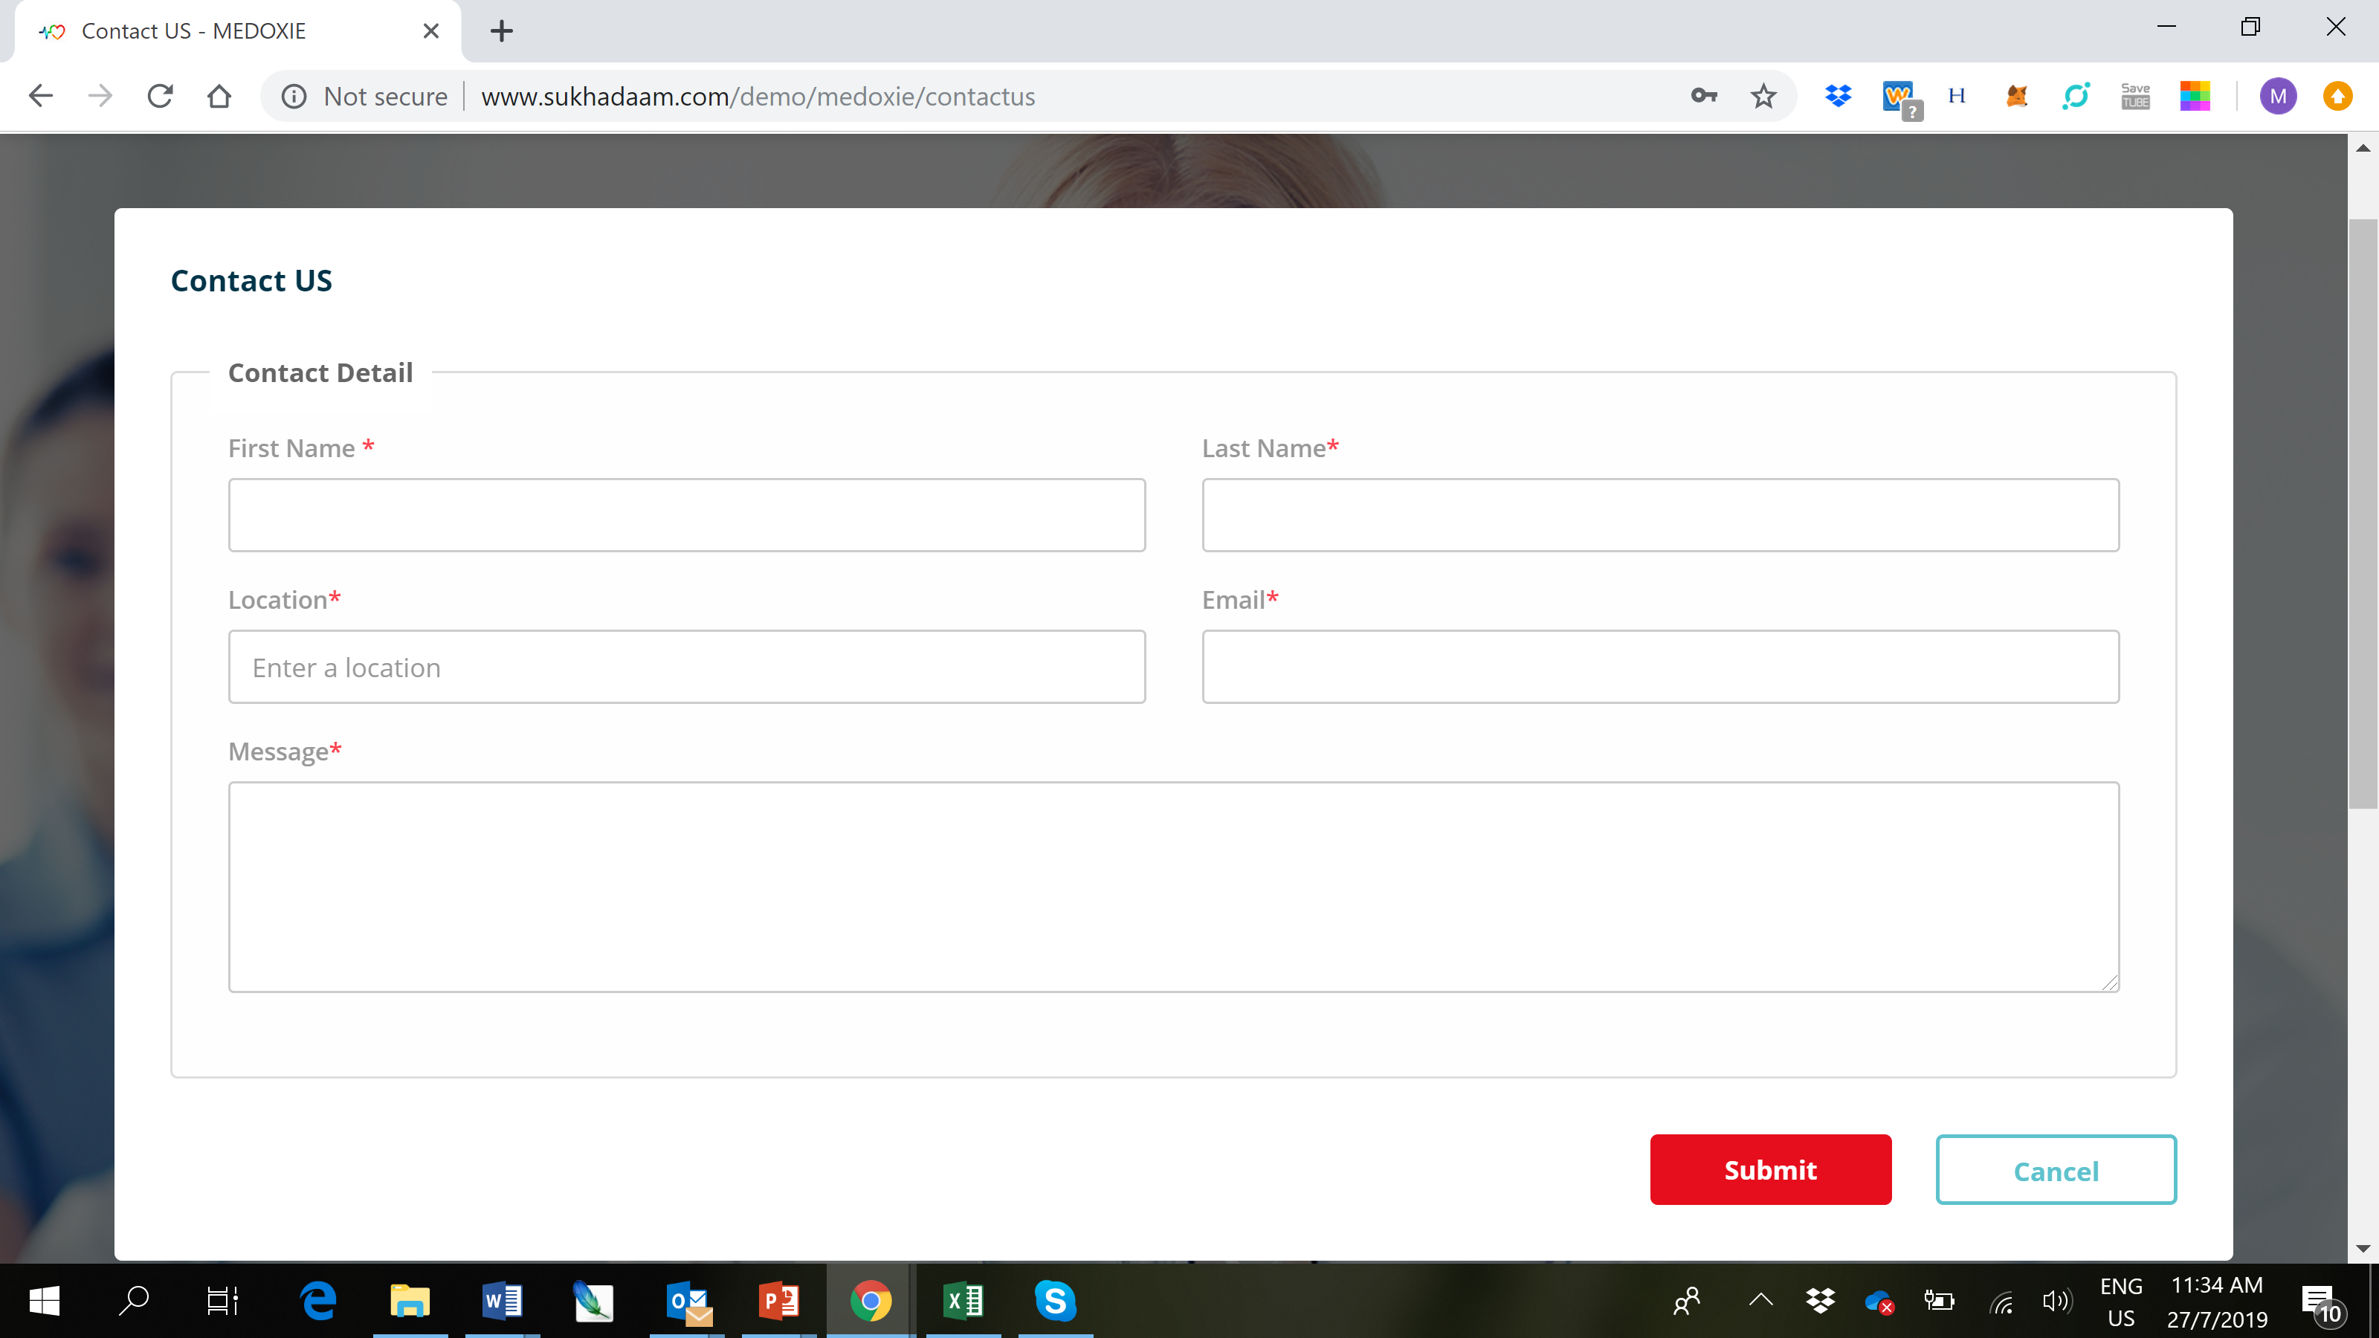

When I press “Cancel” on the “Contact Us” form nothing happens. By pressing cancel the “Contact Us” form should disappear.

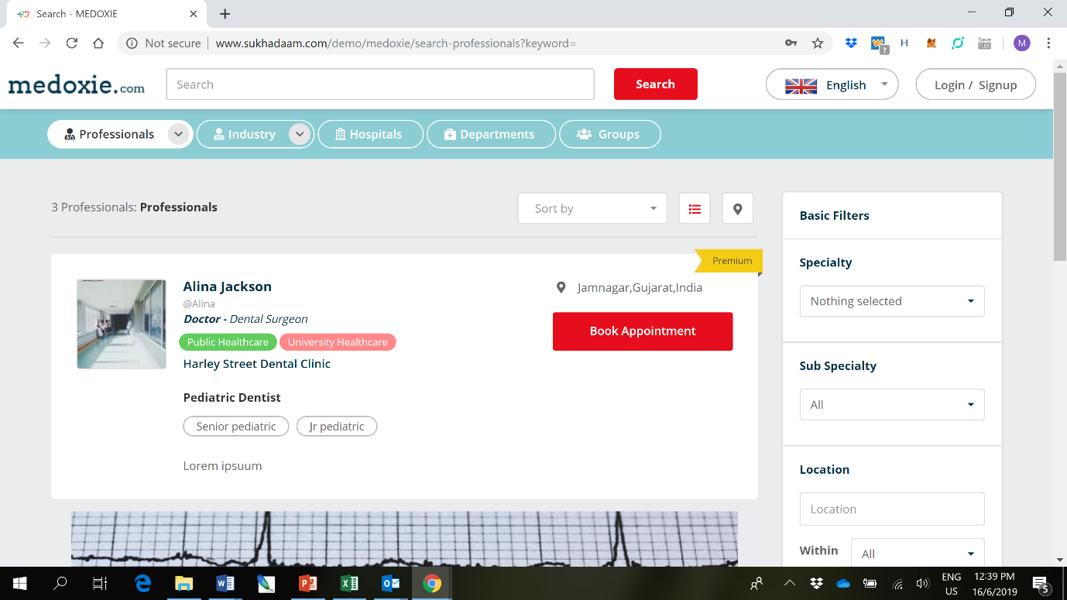

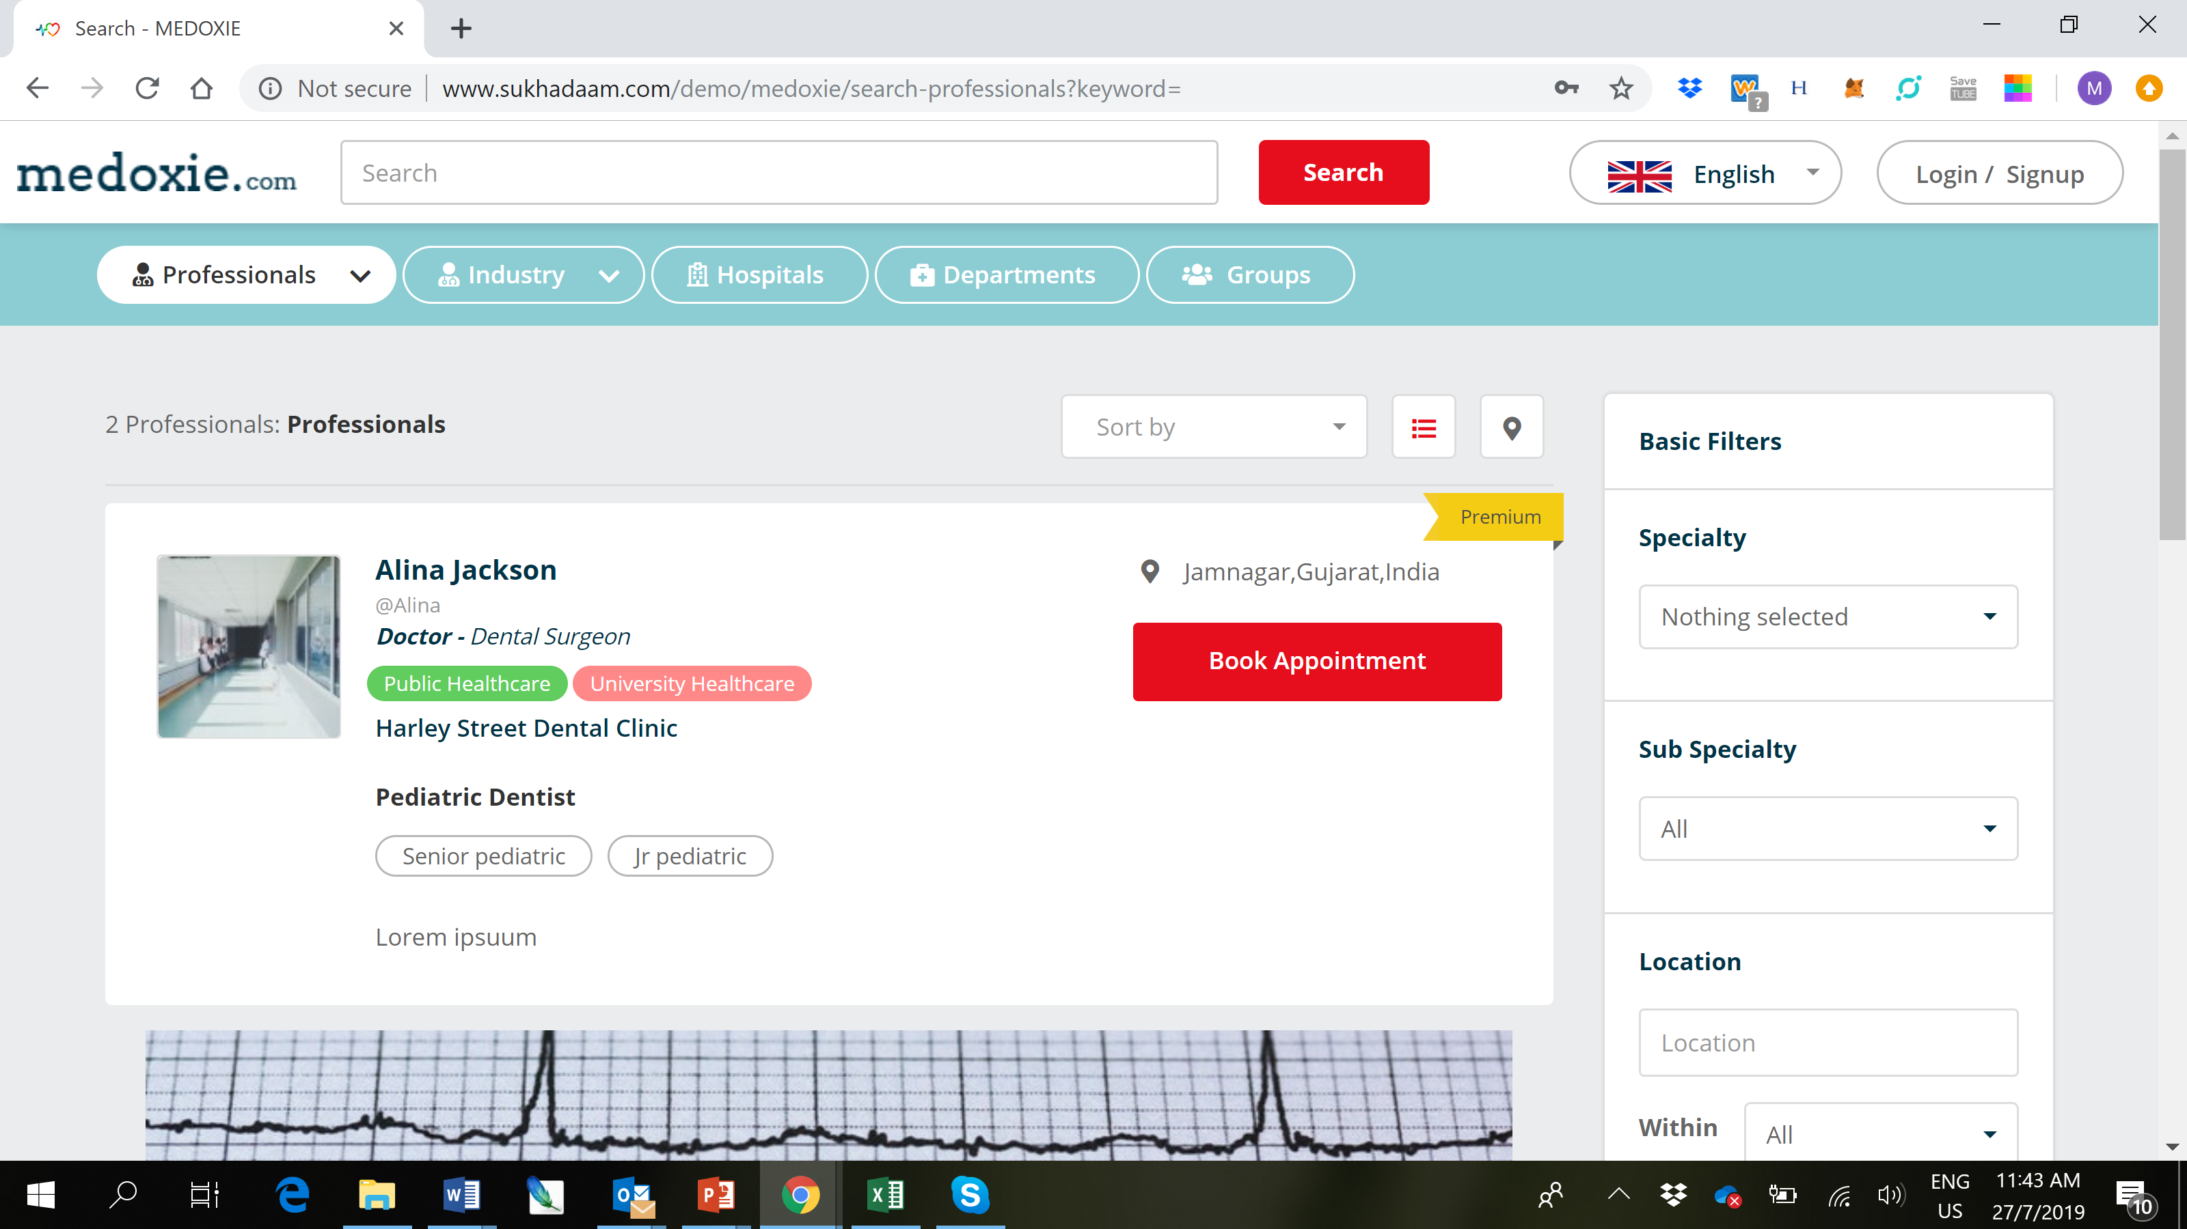

The new version of the website (left image) has lost the really cool animation of the arrows which was on the previous version (right image). When pressing the arrow, the arrow reversed indicating how to minimize the drop-down menu. Also, the arrow had a grey circle background before which looked really good.

Also, there was previously a small gap between the tabs which looked better – would be good to have a small space between the tabs again.

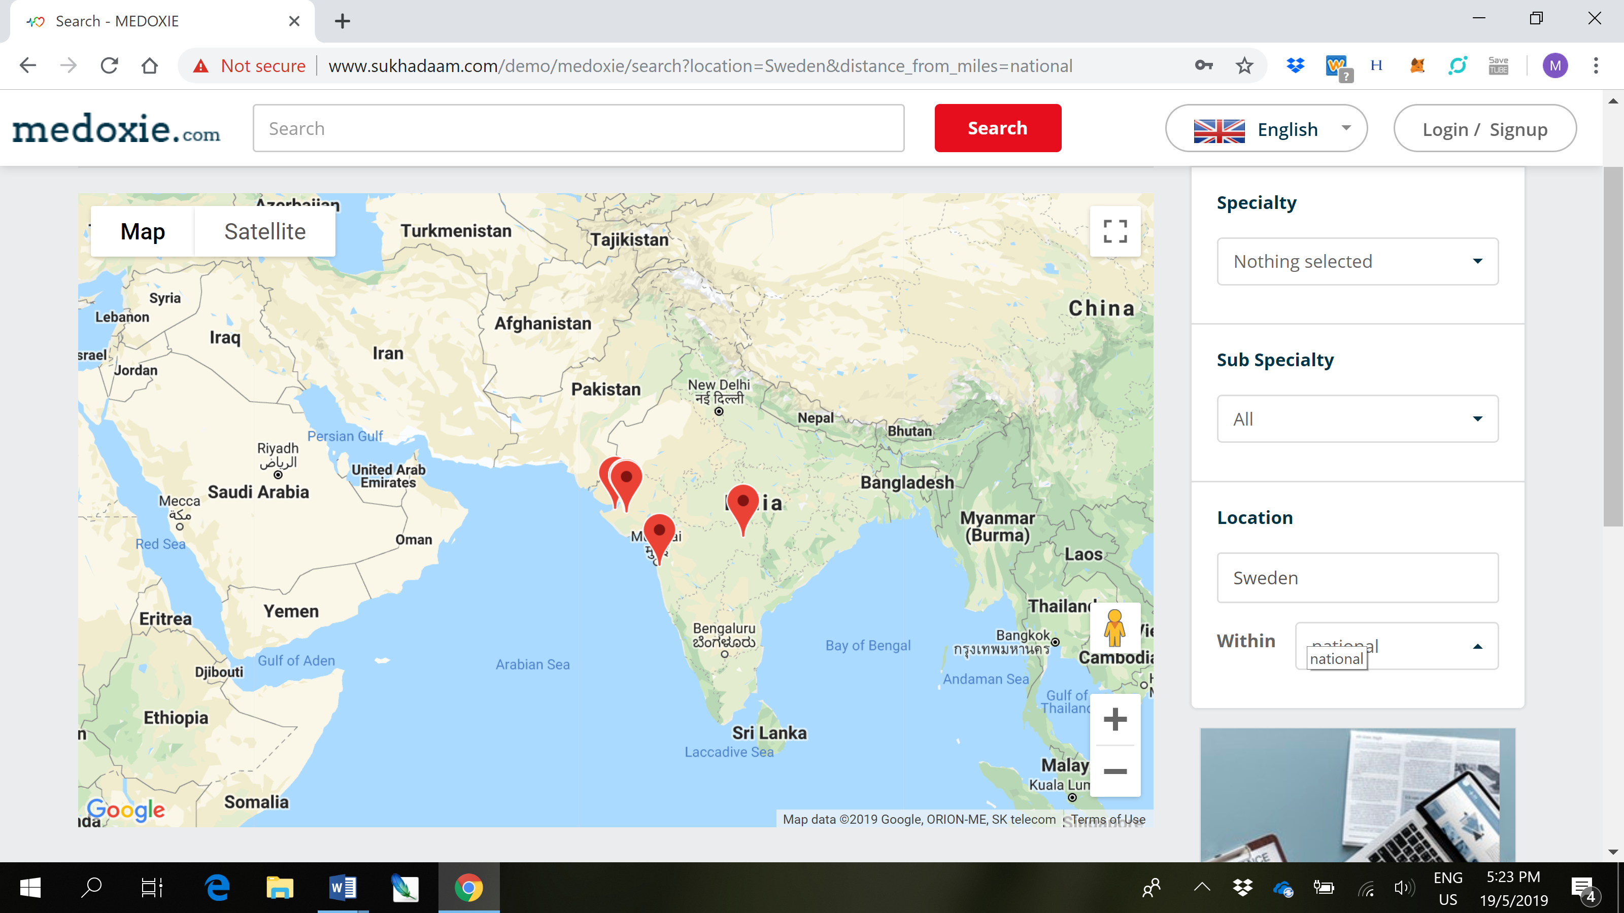

The map function still needs a bit of work. Putting in different locations does not bring up the new location on the map.

MTM (20/05/2019) : Sure, we will update it.

**MT : Pending**

I also remember paying extra to have “Current Location” added as one of the location search possibilities. This is also still pending. Current location should also be the default setting on the search box.

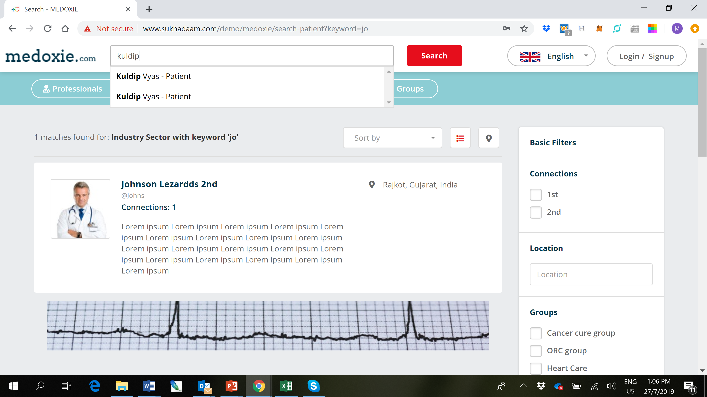

If a user has had their profile deactivated (see below) then their name should not appear in the suggested search terms (see above).

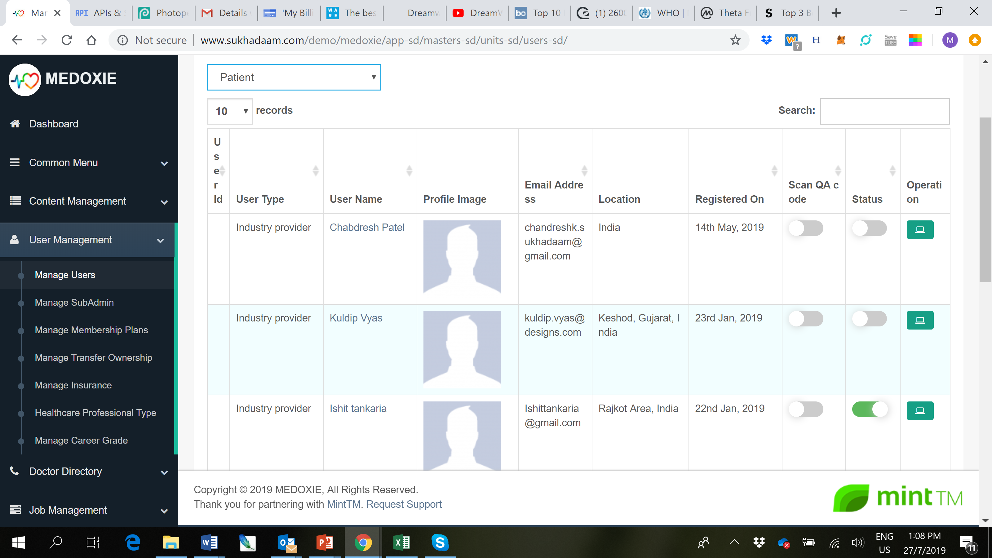

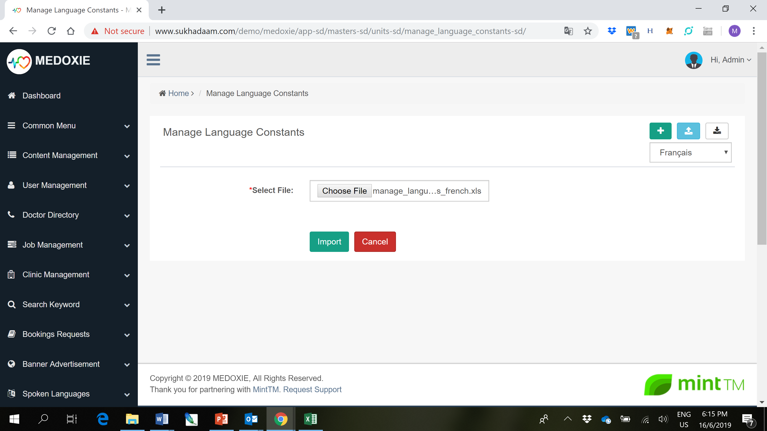

When I upload the French excel file it is the English version of the webpage that gets translated.

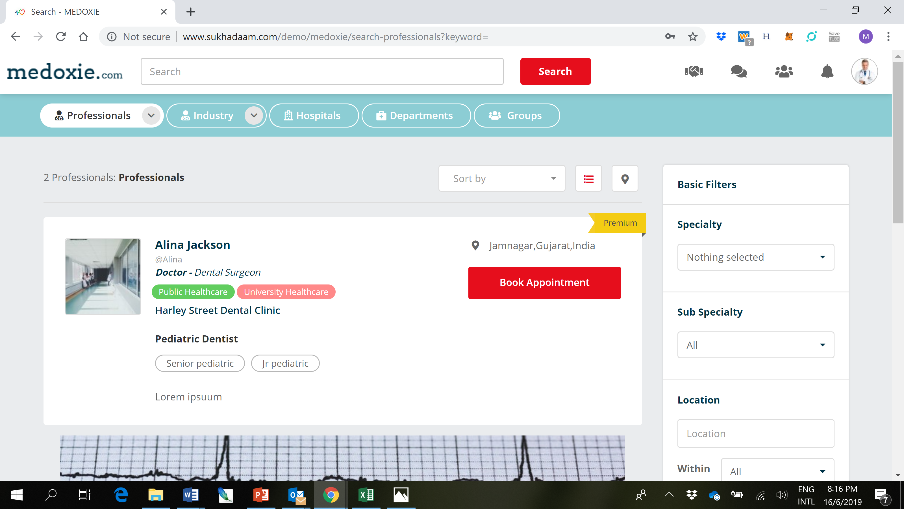

Now that we have changed the “patient” profile to “Industry”, we can add the jobs tab back for the Industry users who are logged in. I am sure the Industry users will use the website to search for jobs for them as well.

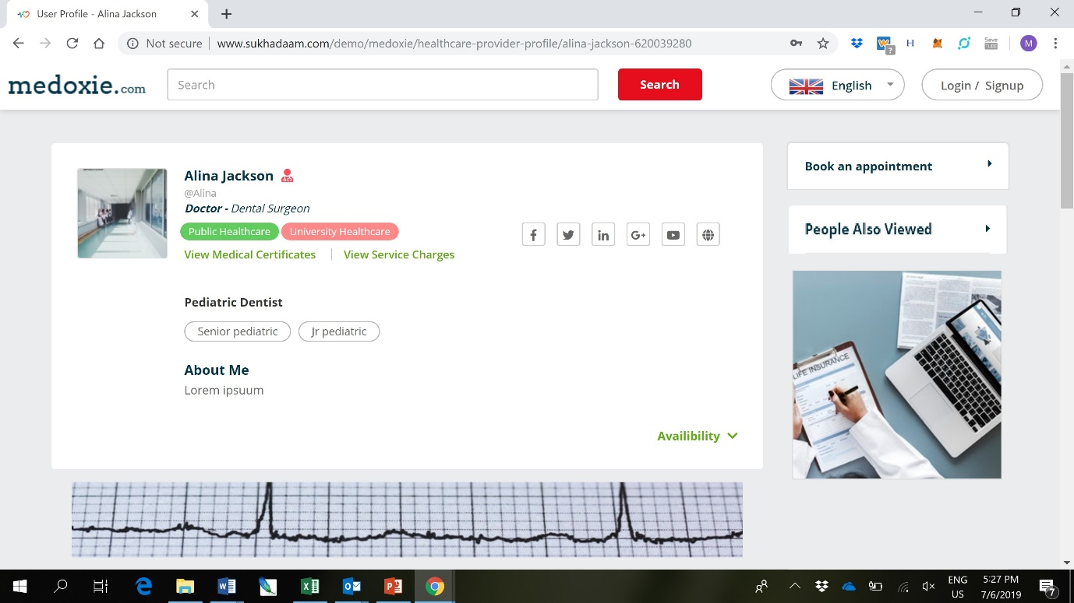

Still waiting for the People Also Viewed tab to be added on the profile page.

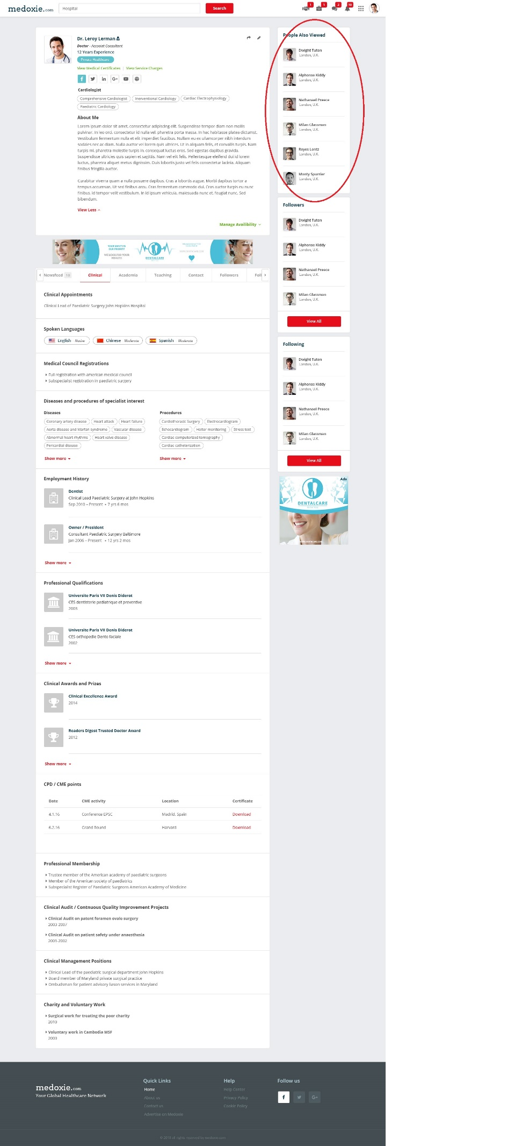

The following questions was sent from MintTM on Skype regarding this issue

Currently, we have considered 'People also viewed' section only for the HCP profiles. Yes I agree – only needed for the HCP pages. Please find the suggested algorithm for this as mentioned below. We have considered the main fields such as Career Grade, Sub-Specialty, Location and Level of Connection

Case 1 (Best Case) - User A is a Patient and he is visiting the profile of User B who is HCP, now in 'People also viewed' section User A will be able to view other HCP Profiles who are having the same Career Grade, Sub-Specialty, Location and 1st Level Connection

Case 2 (2nd Best Case) - User A is a Patient and he is visiting the profile of User B who is HCP, now in 'People also viewed' section User A will be able to view other HCP Profiles who are having the same Career Grade, Sub-Specialty, Location and 2nd Level Connection

Case 3 (3rd Best Case) - User A is a Patient and he is visiting the profile of User B who is HCP, now in 'People also viewed' section User A will be able to view other HCP Profiles who are having the same Career Grade, Sub-Specialty and 1st Level Connection

Case 4 (4th Best Case) - User A is a Patient and he is visiting the profile of User B who is HCP, now in 'People also viewed' section User A will be able to view other HCP Profiles who are having the same Career Grade, Sub-Specialty and 2nd Level Connection

So, Results in 'People also viewed' will be combination of the above 4 cases This appears logical and a very good algorithm for the “people also viewed” column.

Queries -

- We need to know whether he wants to consider the same fields to define the algorithm of People also viewed Or different?

Please go ahead with this algorithm – it looks good to me

- In HCP's profile, Patient/Other HCP can only view results of HCPs in People also viewed panel but Patient's results won't be displayed in People also viewed panel. Correct?

Yes I agree – only need the HCP profiles in the PAV column

- We haven't considered 'People also viewed' section for Patient's profile page so do let me know if you would like to consider 'PAV' section for Patient's profile as this will be additional requirement

At this stage I don’t think PAV for the other profiles are needed.

We will implement the algorithm as discussed.

**MT : Pending**

The industry sectors I would like to control from the admin login (in the same way I can control “Healthcare Professional Type” in the admin).

MTM (20/05/2019) : We will add filter similar to Professionals for industrial but it will require new script to be added for industry so it will be considered as **additional (ETA : 3 Hours)**

**MT : Similar professional filter required new script and though it was additional, we have done that complimentory. Admin management will be additional.**

This has been paid for and I am waiting for the update

When I deactivated the 2FA on the admin login, the following screen is displayed to the user logging in.

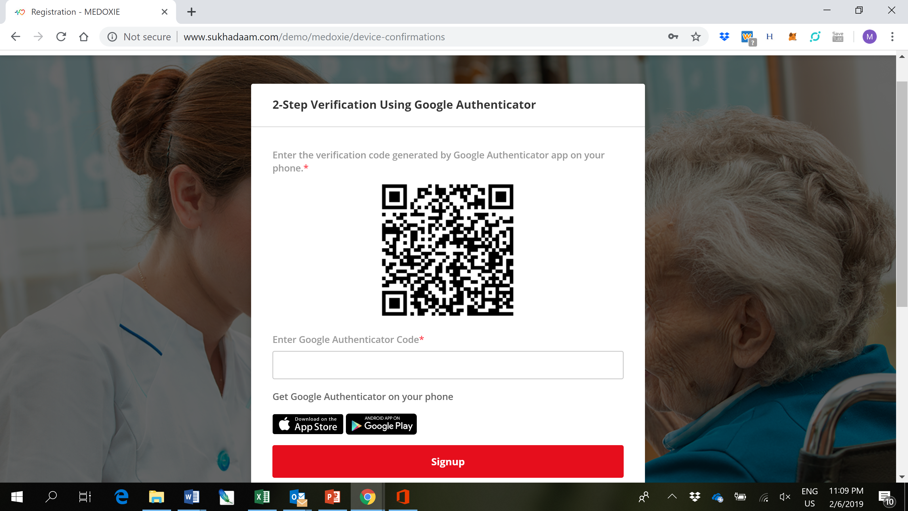

I think it is better that the user is logged into their profile/account if the admin has deactivated the 2FA. If the user wants to reactivate the 2FA then they can do so from their account settings.

**MT : This will be additional.**

This has been paid and I am waiting for the update

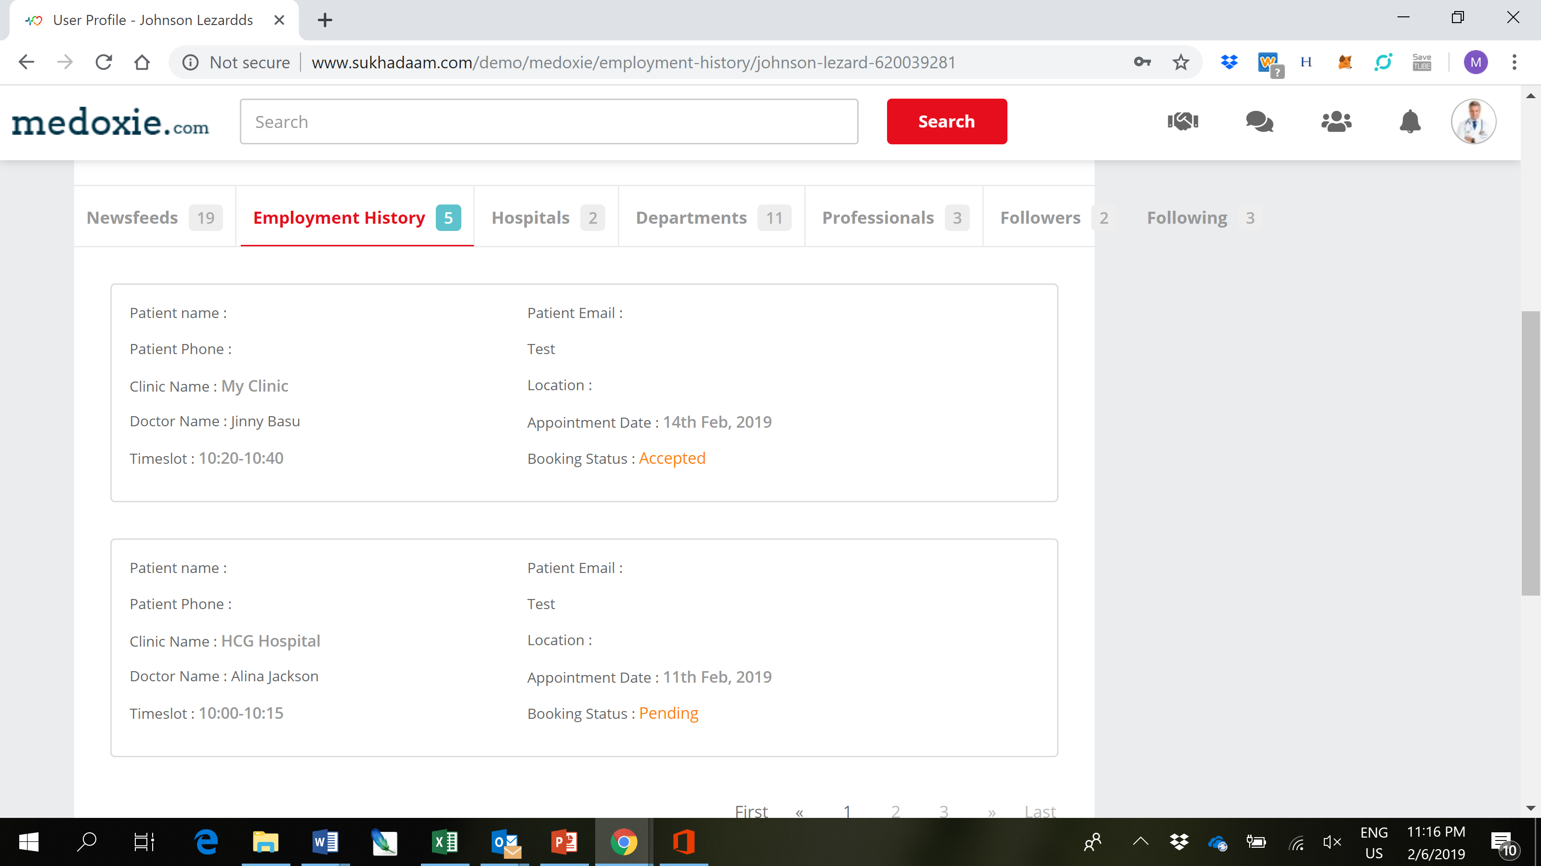

Still pending. Looks good having the extra tab for employment history in the profile.

The formatting of the employment history still needs completing – not displaying correctly

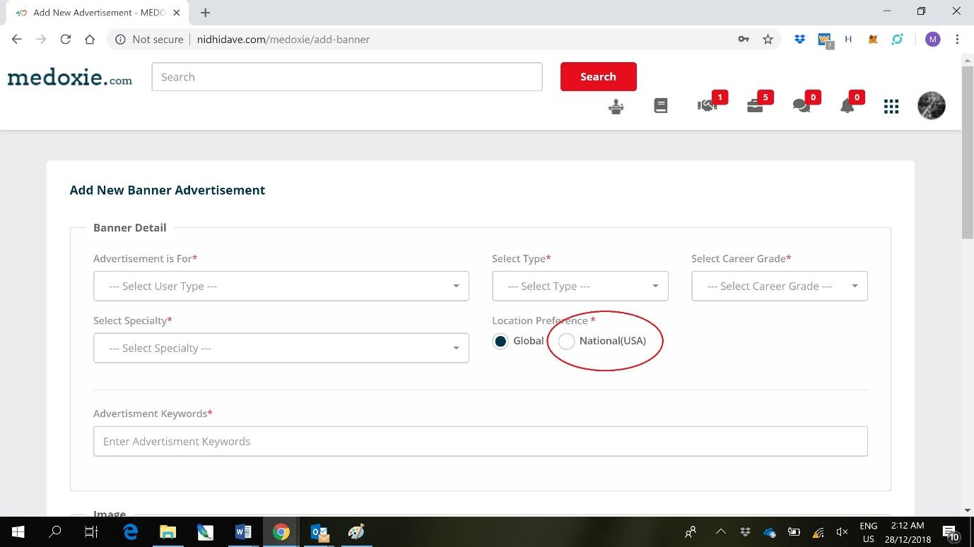

How does the user select which nation to advertise in under the “National” selection? Is it based on current location and is there an option of choosing specific nations to advertise in. For example, an advertiser may want to choose all nations in the Asia Pacific region so there must be an option of choosing multiple nations for the advert.

MTM (20/05/2019) : While submitting banner advertisement, user will have facility to select multiple countries from the dropdown and when someone will open the site from the listed country, based on the IP of the site visitor, advertisement will be displayed. Kindly confirm the flow.

Ok this sounds good - look forward to the update

**MT : Pending**

Still pending and awaiting update

You mentioned in the previous email that cancel appointment is additional and I am happy to pay extra to have this feature incorporated. I recently received an email after booking a restaurant. I notice that they have incorporated a feature where you can “edit/cancel” the appointment. I wonder how this works and whether it is possible to incorporate into our booking service. If a patient wants to “edit” the appointment (i.e. change the appointment to another time slot) is this possible to add as a feature in our booking system? Please let me know how much extra this will cost.



The screenshot above is from a restaurant booking I made recently. The “edit/cancel” feature is a link on the email. I am thinking our booking could work in the same way. Please let mw know what you think and how it could be incorporated on my website.

Paid for this feature to be added and awaiting your update

I’m still considering buying the “staysbnb” but there are some more essential updates (as shown above) that need to be finished first.

Many thanks for all your hard work. Overall the website is looking fantastic!

Kind regards,

Marten